https://shorturl.at/G2IAP 15 Jan 2025

G17 BEE
Frameworks in Node.js
Express Introduction
Serving Static files in express

=================================================
Frameworks of Node.js
=================================================

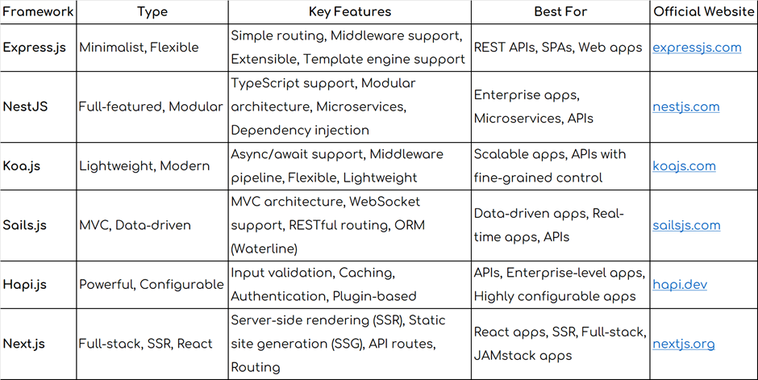

=================================================
Express.js
=================================================
- Type: Minimalist and flexible
- Overview: Express.js is one of the most widely used frameworks in the Node.js ecosystem. It is minimal, unopinionated, and provides a simple API to build robust web applications and APIs. Express handles routing, middleware, template engines, and much more.
- Use Case: Ideal for building RESTful APIs, single-page applications (SPAs), and server-side applications.
Key Features:
- Simple routing
- Middleware support
- Template engine support (e.g., EJS, Pug)
- Robust routing system
- Extensible with many third-party packages

=================================================
Response Methods in Express
=================================================

Method | Purpose | Common Use Cases
res.send() | Sends a generic response (string, object, or buffer). | Sending text, JSON, or binary data.
res.json() | Sends a JSON response. | Returning JSON data in APIs.
res.jsonp() | Sends a JSONP response. | Supporting cross-origin requests.
res.sendFile() | Sends a file as the response. | Serving static files like HTML, images, PDFs, etc.
res.status() | Sets the HTTP status code. | Indicating the success or failure of the request.
res.redirect() | Sends an HTTP redirect response. | Redirecting to another URL.
res.render() | Renders a view and sends the HTML output. | Rendering dynamic HTML views using a templating engine.
res.set() | Sets HTTP headers. | Customizing response headers (e.g., for caching or content type).
res.type() | Sets the Content-Type header. | Setting content type shorthand (e.g., JSON, HTML).
res.sendStatus() | Sends a status code with a default message. | Sending just a status code (e.g., 404 Not Found).
res.location() | Sets the Location header (often with 3xx/201 responses). | Indicating the URI of a new or redirected resource.
res.vary() | Sets the Vary header. | Indicating response variations based on request headers.

Example
//initialyse project
//>npm init -y
//download express module
//>yarn add express --save
//import express module
let express = require('express')
//create rest object
let app = express() //where app is rest object
//create get request
app.get("/",(req,res)=>{
console.log('Default get message')
res.json({'message':'default get request'})
})
//create one more get request
app.get("/fetch", (req, res) => {
res.send({ 'message': 'fetch get request' })
})
//create post request
app.post("/", (req, res) => {
res.send({ 'message': 'default post request' })
})
//create one more post request
app.post("/login", (req, res) => {
res.send({ 'message': 'login post requrest' })
})

//create a port
let port = 8080
//assign port no
app.listen(port, () => {
console.log('Server listening port no ', port)
})

/*
Test urls with postman
http://localhost:8080 Default GET
http://localhost:8080/fetch fetch GET
http://localhost:8080 Default POST
http://localhost:8080/login login POST
*/

=================================================
Serve Static Files
=================================================
- static() is the predefined function from express.
- This function is used to set the target directory.
- Argument to this function is path.

Directory Structure
<>
public
- notes.txt
- index.html
- server.js

***note.txt***
these are the important notes of Node.js

***index.html***
<!DOCTYPE html>
<html>
<head>
<title>Express static</title>
<link rel="icon" href="https://expressjs.com/images/favicon.png" type="image/x-icon">
</head>
<body>
<h1 style="color: red;">Welcome to static files in express</h1>
</body>
</html>

***server.js***
// Import the express module
const express = require('express')
// Create an Express application
const app = express()
// Serve static files from the 'public' directory
app.use(express.static('public'))
// Define a route to handle a basic request to the root of the app
app.get("/", (req, res) => {
res.send("Welcome to the static files server!")
})
// Start the server and listen on port 8080
const port = 8080
app.listen(port, () => {
console.log(`Server is running on http://localhost:${port}`)
})

